1. Create on Bash script to check if a directory is available or not.

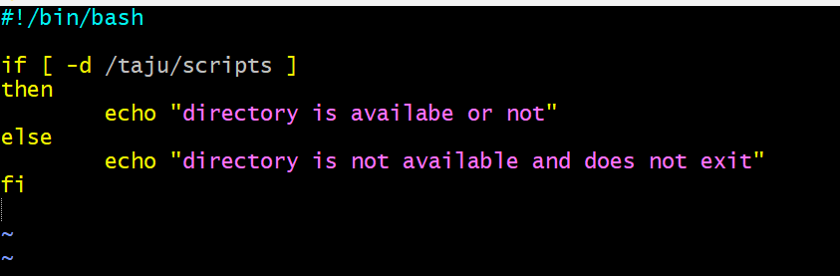

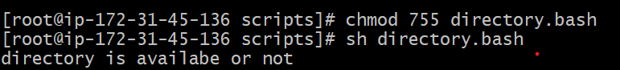

The path is change

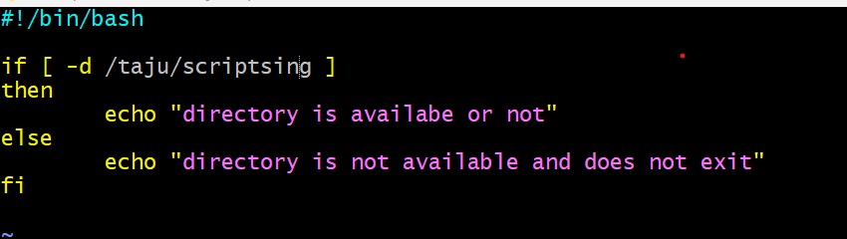

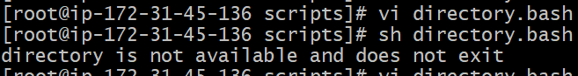

1. Create a bash script which will create multiple files.

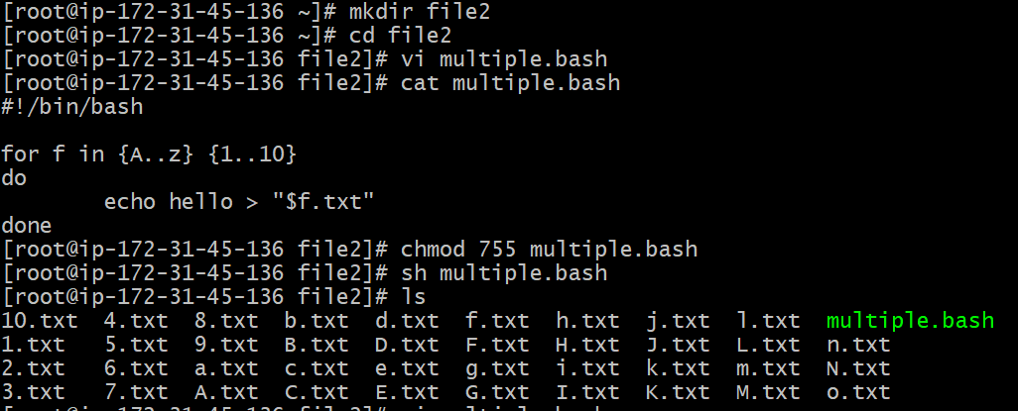

1. Create a bash script to take backup of a directory.

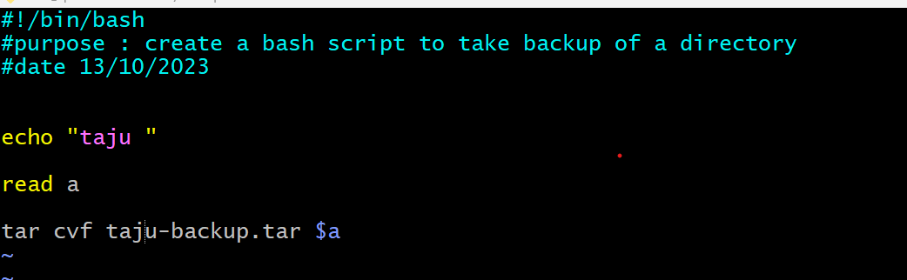

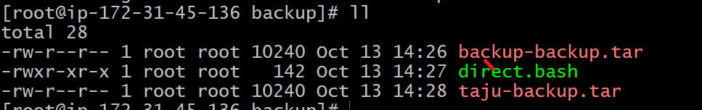

4)Create a bash script to install nginx in ec2 server.

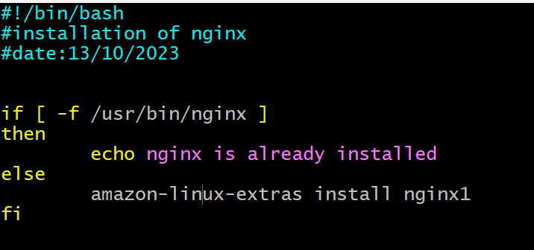

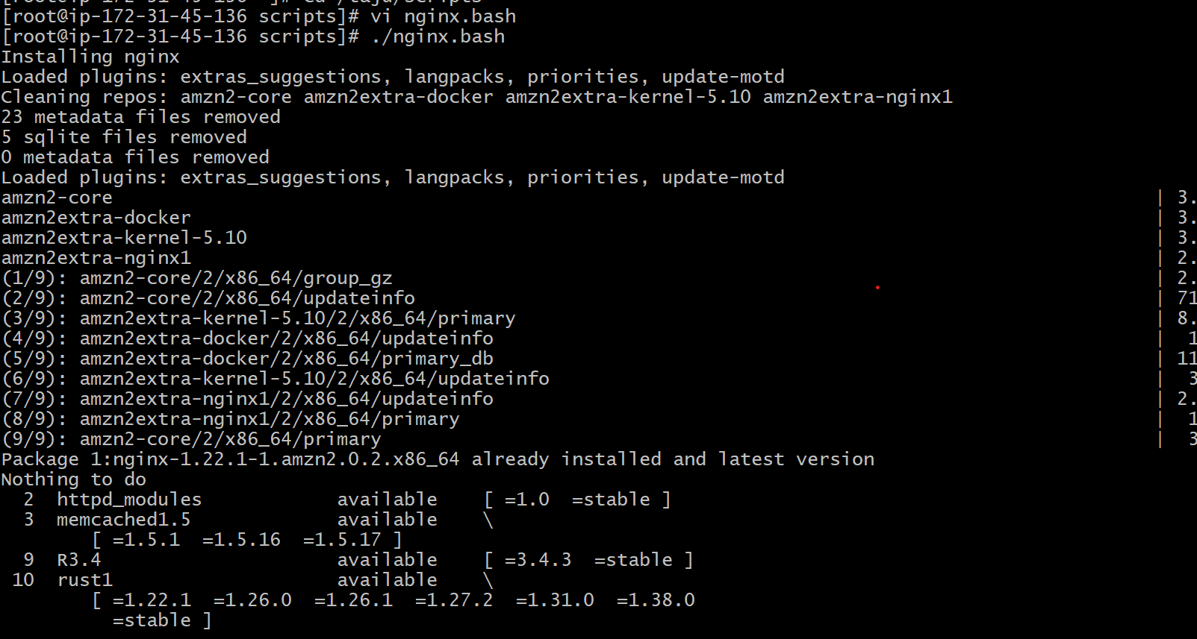

5) Create a bash script to install Apache Tomcat in ec2 server.

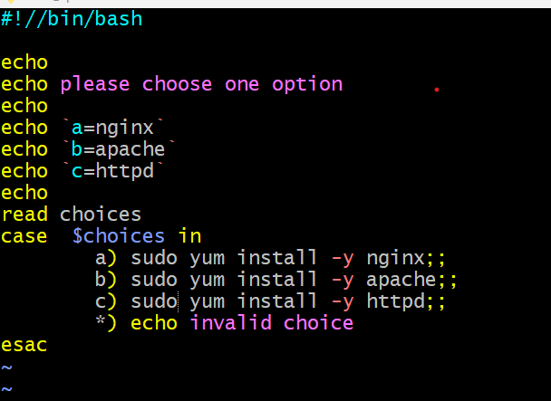

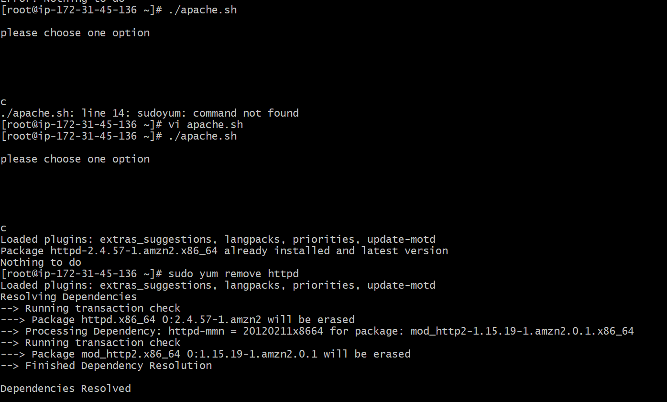

6) Create a bash script to check list if nginx service is running or not,if not running

then script should start the service.

7) Create a bash script for calculator.

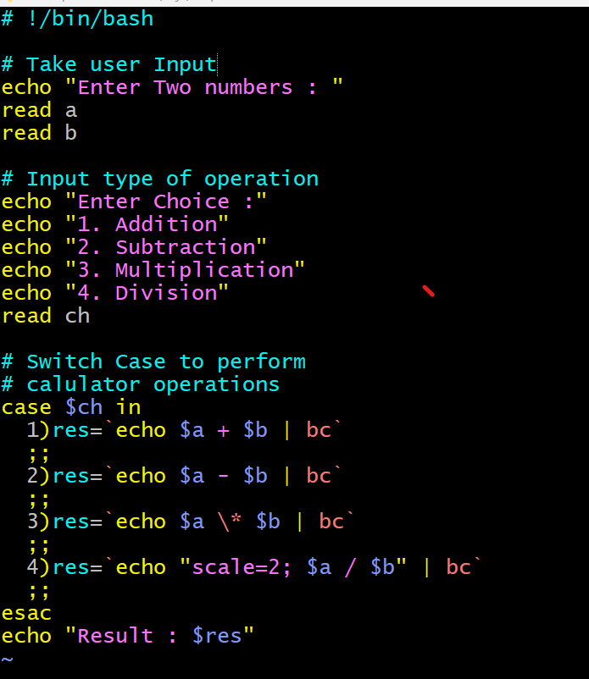

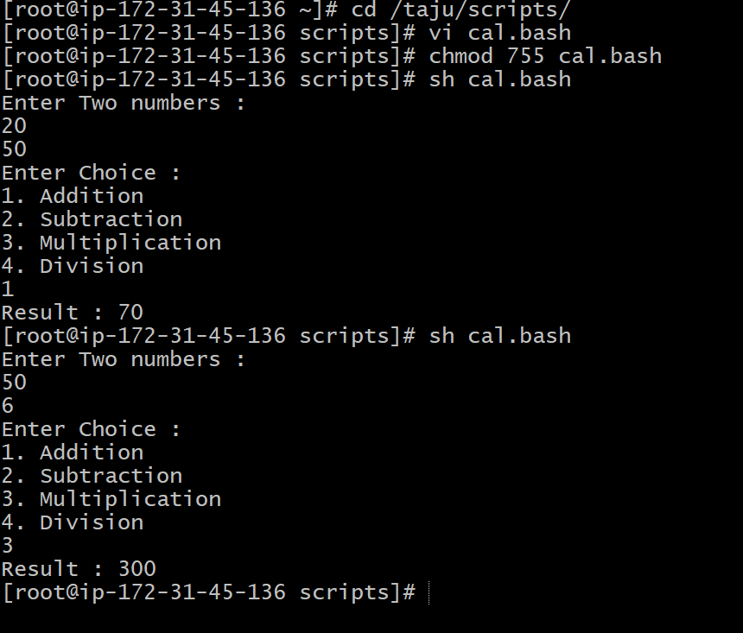

8) Create a bash script to check if directory is avaialble or not,if not then create a directory.

9) Create bash script to delete last 3 lines for a file.